Azure Cosmos DB It is a NoSQL database.
NoSQL With huge data or big data we have three problems : Volume, Velocity and Variety. Relational databases like SQL Server, Oracle aren’t designed for handling huge volumes of data. When database size grows we need powerful CPUs, powerful RAMs, huge volumes of hard disk spaces i.e.. the server has to grow exponentially. So at some point we can’t rely on a single big machine handling the entire volume of data (data in tera bytes or peta bytes) within itself. The solution for this is scale out to multiple machines.

Relational databases scale up
NoSQL databases scale out
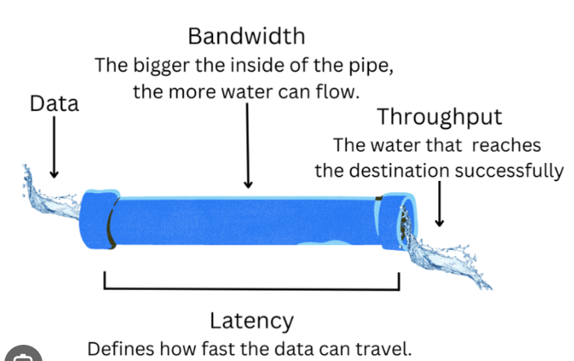
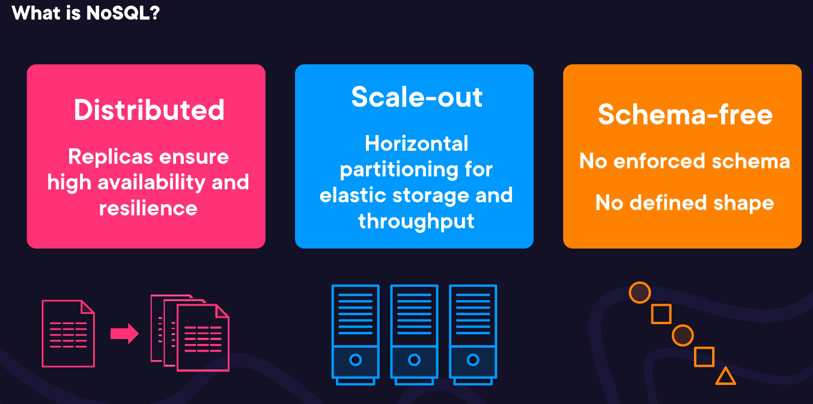
Azure Cosmos DB:
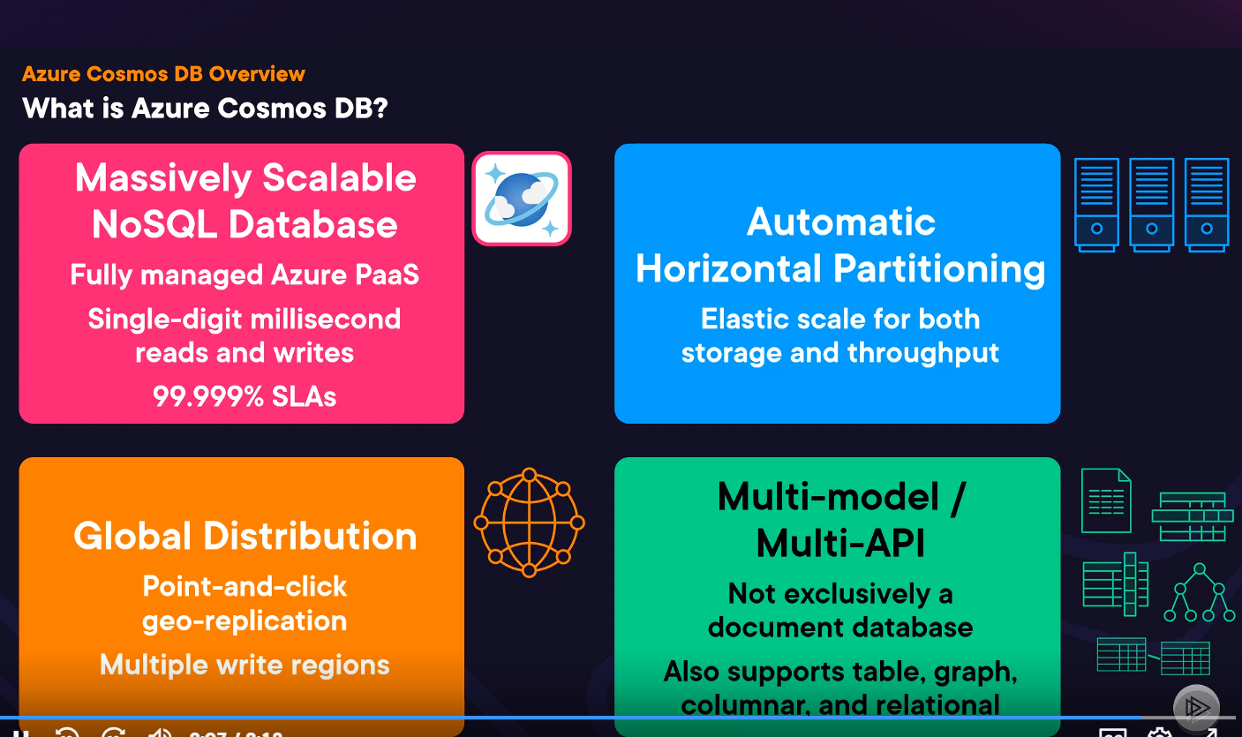
Why SQL Server stores data in more space but Azure Cosmos DB takes less space ?
Factor | SQL Server | Cosmos DB
Storage model | Fixed 8 KB pages | Binary document store
Schema | Rigid | Schema-less
NULL handling | Costs space | Free
Index storage | Heavy, duplicated | Optimized, shared
Compression | Optional | Always on
Reported size | Physical allocation | Often logical size
Sparse data | Inefficient | Very efficient

Bottom line
Cosmos DB appears smaller not because JSON is smaller, but because:
- SQL Server has page + index + schema overhead
- Cosmos DB uses aggressive internal compression
- Cosmos reports logical size, not full physical footprint
- Schema-less storage avoids wasted space

Types of Data Models: 